Design Thinking For Software Engineers
Lab-2
E-learning platforms fail to keep learners engaged
Name: Nivedh Sunil Roll No.: 24BTCE111
1. Context
Students, Teachers and working individuals use E-Learning Platforms for:
- Learning new courses
- Assigning courses
- Upskilling for better work opportunities
2. Target Users
- Students:
  - Age: 13-24
  - Digital Literacy: medium to high
- Instructors:
  - Age: 35-55
  - Digital Literacy: medium to high
- Corporate Learners:
  - Age: 25-45
  - Digital Literacy: medium to high
3. Initial Assumptions
- Lack of proper UI/UX designs.
- Most of the learning contents are long videos and presentations which lack in interactivity to keep the learning platform engaging.
- Few platforms are text-heavy, making it less engaging and people start to divert from the platform.
- Lack of user specific content leading to incompletion rates and frustration.
Output:
Assumption Id | Assumption
A1 | The findings strongly represent the needs and pain points of the Student demographic, specifically the 18-24 age group.
A2 | The necessity for diverse content (short modules/visuals) is a critical, high-priority requirement for improving platform engagement.
A3 | User actions like "Skip sections" or using "AI tools to summarise it" are clear behavioural indicators of high cognitive load and time-sensitivity, not just laziness.
A4 | The most effective interactive features are those that provide immediate feedback and active engagement rather than passive consumption.
A5 | The stated problems (e.g., repetitive formats, confusing navigation) are assumed to be direct, primary causes of user disengagement and course incompletion.
A6 | Respondents possess sufficient technological literacy and access to utilize advanced tools like ChatGPT, which influences their learning behaviours.

4. Interview Questions
- Tell me about the last online course you started but didn’t finish. What made you stop?
- How do you feel when a course has long videos or heavy text content?
- What usually goes through your mind when the platform is confusing or hard to navigate?
- What do you actually do when you see long text sections or repetitive lessons?
- What frustrates you most about current e-learning platforms?
- If you could change one thing to make online courses more engaging, what would it be?
5. Interview Notes and Quotes
Name: Santhosh KV
Age: 45
Occupation: Professor
- Interview Notes:
  - He reported that many students skipped course material and focused mainly on receiving the completion certificate.
  - He expressed feelings of anger and frustration, stating that learners did not understand the importance of the assigned courses.
  - He observed that long, text-heavy sections were skipped most often.
  - He mentioned that identifying suitable and engaging courses for assignment was a difficult and time-consuming process.
  - He felt that current e-learning platforms were not effective at sustaining student attention.
  - He believed platforms prioritized quantity of content over quality of learning experience.
- Quote:
  - “The current e-learning platforms are not capable enough to pull the audience.”
Name: Shijith M
Age: 28
Occupation: Working IT professional
- Interview Notes:
  - He reported that high-quality courses were often expensive, while free courses tended to lack quality.
  - He felt frustrated that poor UI/UX reduced his interest in learning.
  - He stated that long, non-interactive videos were annoying mainly because of technical lag.
  - He admitted to skipping long text sections and suggested boredom might lead to incompletion.
  - He felt animated visuals and more attractive design could improve engagement and reduce dropouts.
  - He rated the need for diverse formats as moderate and tolerated repetition when the topic felt new.
- Quote:
  - “Making the platform more visually attractive would reduce dropout”
Name: Ridit Santhosh
Age: 14
Occupation: Student
- Interview Notes:
  - He stated that the course visuals were appealing but the explanations were unclear.
  - He felt frustrated and discouraged by timed problem-solving activities for complex equations.
  - He reported feeling sad when he was unable to complete problems within the given time.
  - He noted that the lack of interactivity left his doubts unresolved.
  - He linked unresolved doubts to lower grades and eventually quitting the course.
- Quote:
  - “There was no way to ask doubts.”
  - “My grades went down, so I stopped the course.”

6. Empathy Map
Name: Santhosh KV
Age: 45
Occupation: Professor

Name: Ridit Santhosh
Age: 14
Occupation: Student

Name: Shijith M
Age: 28
Occupation: Working IT professional

7. Validation of Assumptions
Assumption | Validated? | Reason from Interviews
Lack of proper UI/UX designs | Yes | Shijith stated poor UI reduced interest. Santhosh felt platforms failed to hold attention, confusing navigation lowered engagement.
Long videos and low interactivity reduce engagement | Yes | Shijith complained about lag and non-interactive videos. the student reported no interactivity to resolve doubts. the professor observed widespread skipping.
Text-heavy content causes disengagement | Yes | Both Santhosh and Shijith noted long text was skipped. Ridit preferred visuals and struggled with explanations.
Lack of user-specific content leads to incompletion and frustration | Partially | Santhosh observed low completion and frustration. Ridit quit due to mismatched pacing and timers. personalization was implied but not explicitly stated by all users.

8. User Insights
- Learners chase certificates when courses fail to keep them engaged.
- Poor UI/UX causes dropout before users even realize they’ve disengaged.
- Students quit when they cannot ask questions or clear doubts.
- Timed challenges frustrate learners when pressure replaces support.
- Instructors distrust platforms when they cannot find quality courses easily.
- Users abandon courses when visuals look good but explanations are unclear.
- Free courses lose credibility when quality feels low.
9. User Persona
Person 1
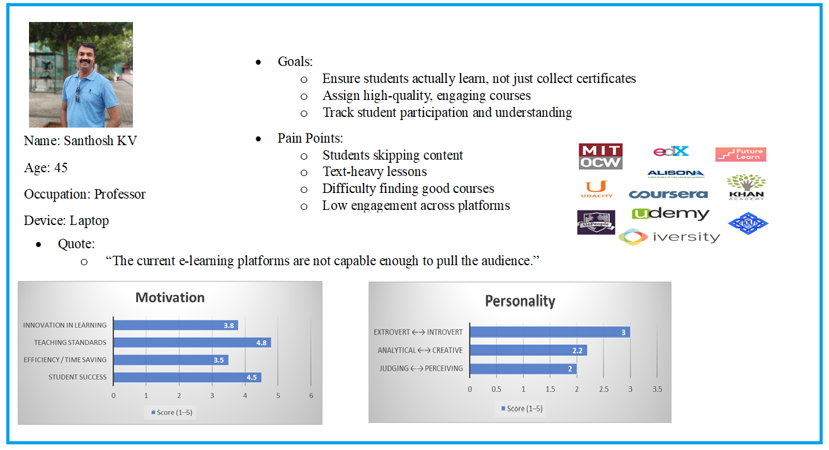
Person 2
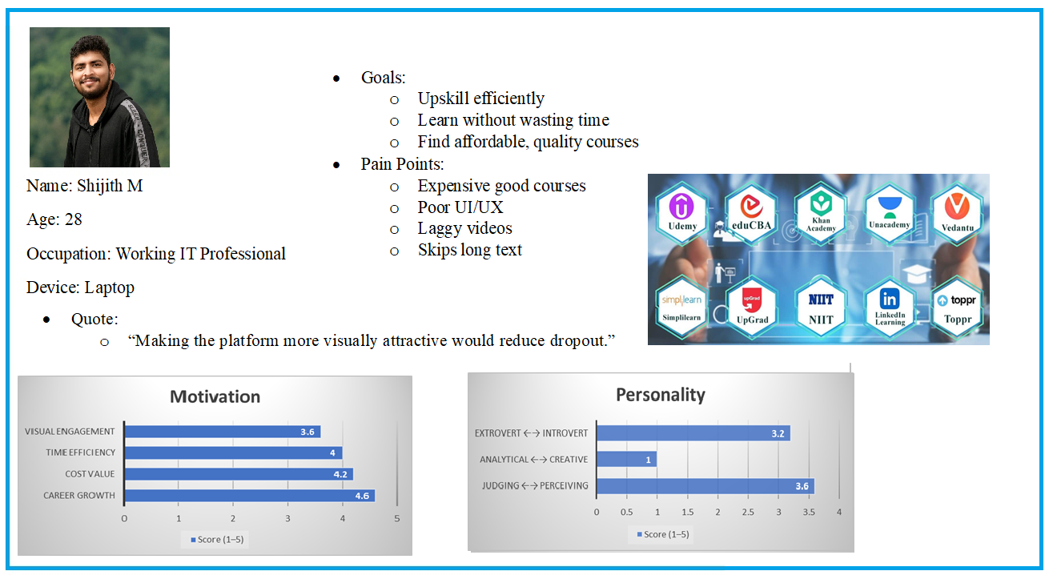

Person 3
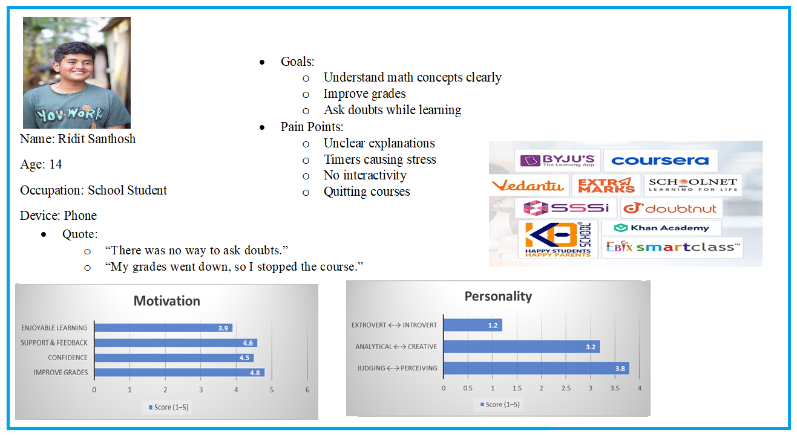
10. Software Requirements
Insight | Software Requirement
Learners drop out when courses feel boring or repetitive | Short modules, varied formats, micro-learning
Poor UI/UX reduces motivation quickly | Clean layouts, intuitive navigation, fast loading
Students quit when doubts remain unresolved | Live chat, doubt-clearing forums, AI tutor
Timed tasks discourage weaker learners | Adjustable timers, practice mode
Instructors struggle to find quality courses | Instructor dashboards, rating filters, preview tools
Users skip long text content | Visual explanations, summaries, collapsible sections
Professionals distrust free courses | Quality badges, reviews, sample lessons
Visual polish raises expectations | Clear instruction design, learning objectives

11. Reflection And Documentation
- What surprised you?
  - Learners skipped content even when visuals were good. Instructors also struggled to find quality courses.
- Which assumption was wrong?
  - Disengagement wasn’t only due to text-heavy content, lack of interactivity, pacing, and stress also mattered.
- How did empathy change your thinking?
  - I realized motivation, confidence and emotional experience drive engagement as much as usability.
- How will this affect design?
  - Design must focus on interactive, bite-sized content, clear instructions, adaptive pacing, doubt resolution and tools for instructors to assign quality courses.

